Name: Barathkumar J K

Shell scripting project

1. Sum of all positive numbers in an array

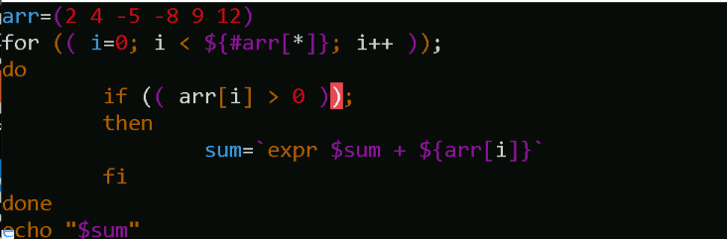

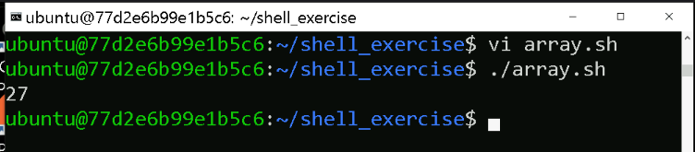

1. Reverse the number

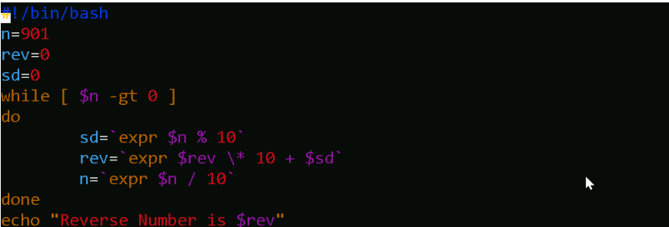

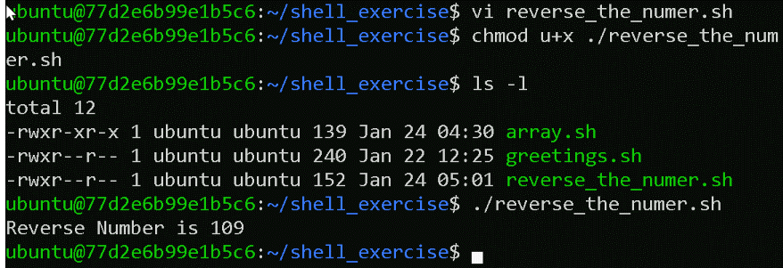

1. Palindrome number

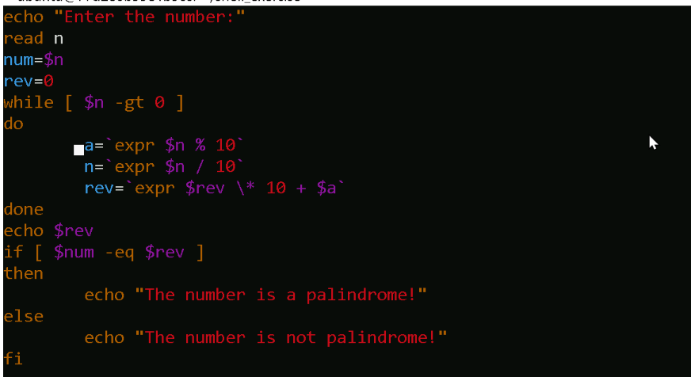

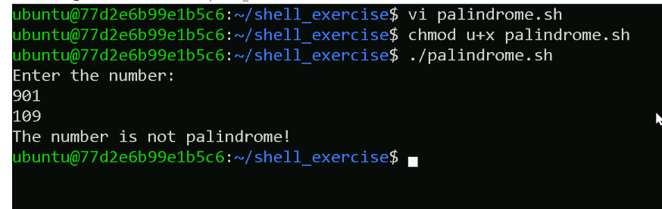

1. Bubble sort

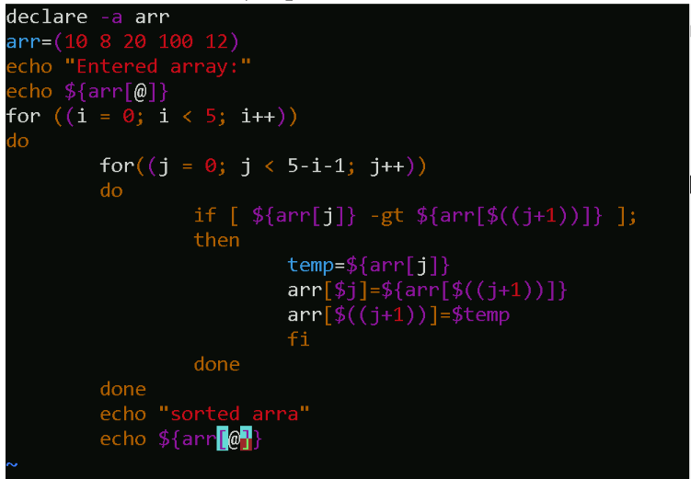

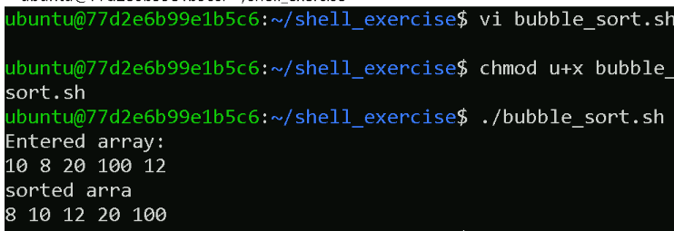

1. Pascal Triangle

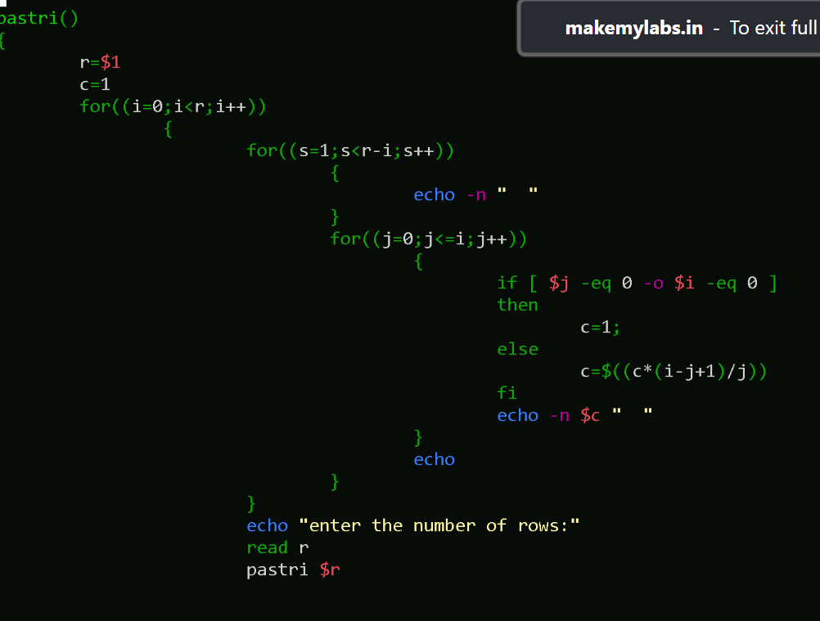

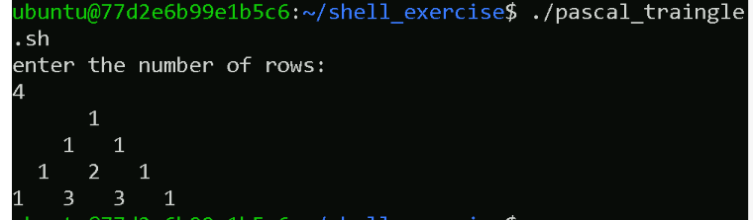

1. Shell program to add two integer values and check if any input is given or not

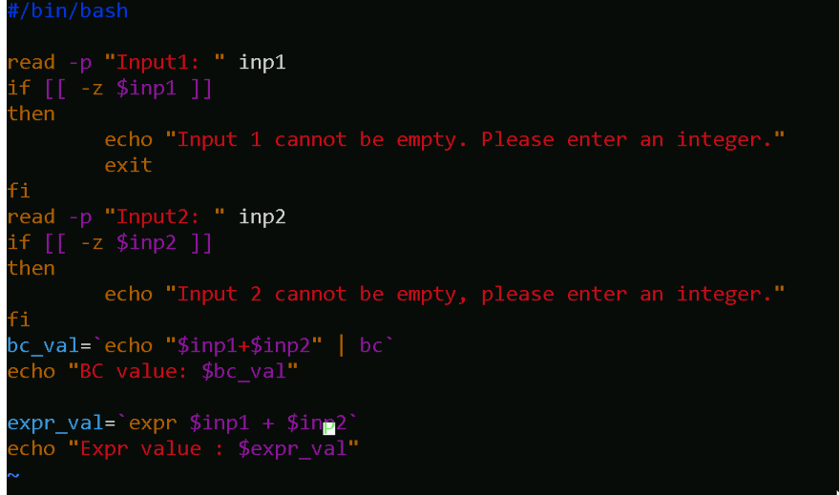

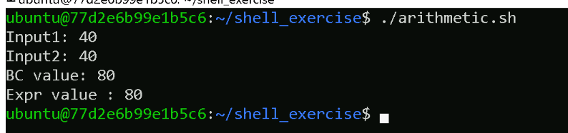

1. Hello greetings

